**DIGICOTS**

**(Design Brief for Digicots Website)**

**[Created by: Anugreh Koul]**

**Home Page**

**In Place of Complacency Curve**

**NOTES:**

* **The following are not different sections for different steps; they are rather one section with animations/transitions conveying all four steps.**

**Reference/Inspiration:**



[**https://www.utsubo.com/**](https://www.utsubo.com/)

**User Input:** Scroll Down after Showreel end

**Output:** Glance Wolf eyes on pitch black screen

**Instructions:**

* Place eyes in the center as in the reference snapshot/link
* Fade in text below the eyes (with center alignment)

**Content:**

*Your vision becomes our obsession.*

**Reference/Inspiration:**

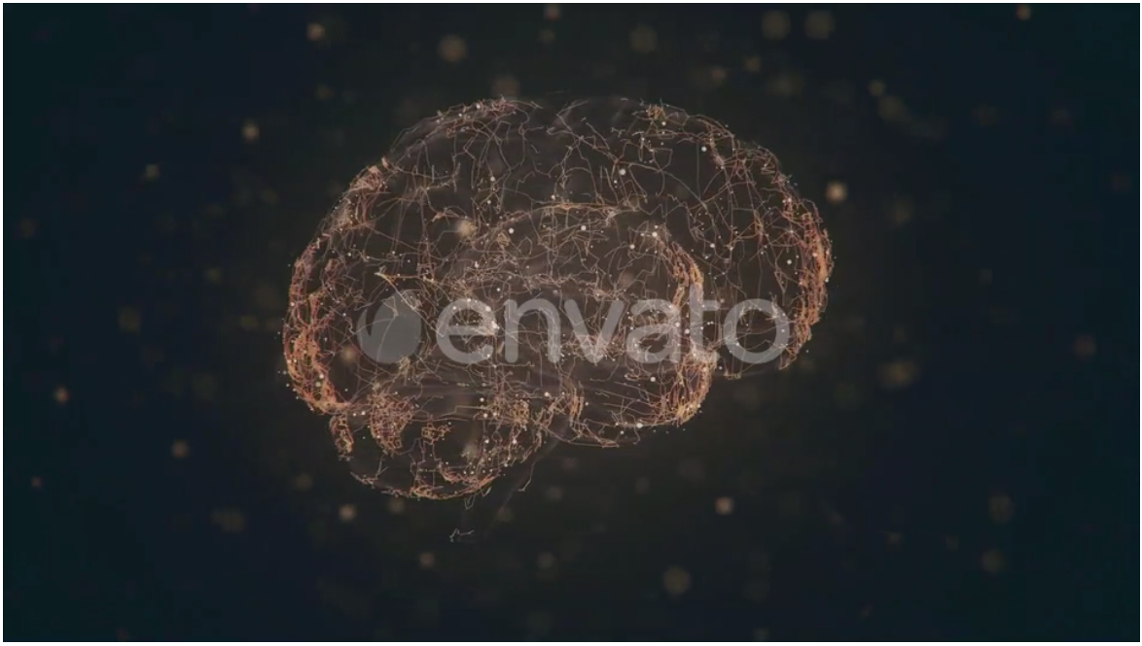

[**https://elements.envato.com/digital-hi-tech-brain-4k-ZQX86LD**](https://elements.envato.com/digital-hi-tech-brain-4k-ZQX86LD)

**User Input:** Scroll Down from eyes screen

**Output:** Close wolf eyes; Slide in 3D brain from left

**Instructions:**

* Place brain on the left side of screen as in the reference snapshot/link
* Fade in text on the right side of screen (with center alignment)

**Content:**

*Observing & understanding the consumer.  
Crafting precise strategies.*

**Reference/Inspiration:**

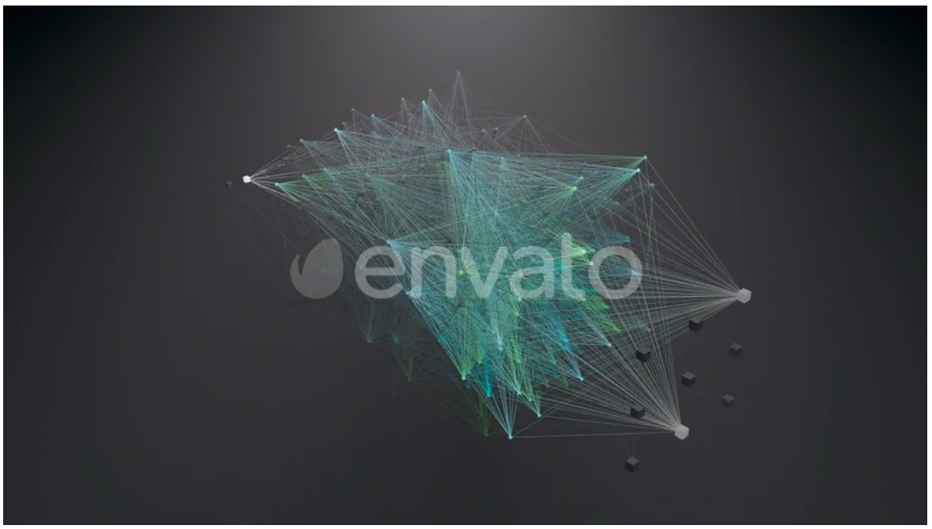

[**https://elements.envato.com/neural-network-visualization-fullhd-CS4HENT**](https://elements.envato.com/neural-network-visualization-fullhd-CS4HENT)

**User Input:** Scroll Down from brain screen

**Output:** Move brain to the right side of the screen; Expand brain into neural network

**Instructions:**

* Place neural network on the right side of screen as in the reference snapshot/link
* Fade in text on the left side of screen (with center alignment)

**Content:**

*This isn’t execution.  
This is a movement.*

**Reference/Inspiration:**



[**https://www.utsubo.com/**](https://www.utsubo.com/)

**User Input:** Scroll Down from neural network screen

**Output:** Slide out neural network to the right; transition screen to pitch black;

bring in wolf eyes (blink once)

**Instructions:**

* Place eyes in the center as in the reference snapshot/link
* Fade in text below the eyes (with center alignment)

**Content:**

*Looking for shifts & threats -   
monitoring, refining & evolving your systems.*

**Footer**

**Reference/Inspiration:**

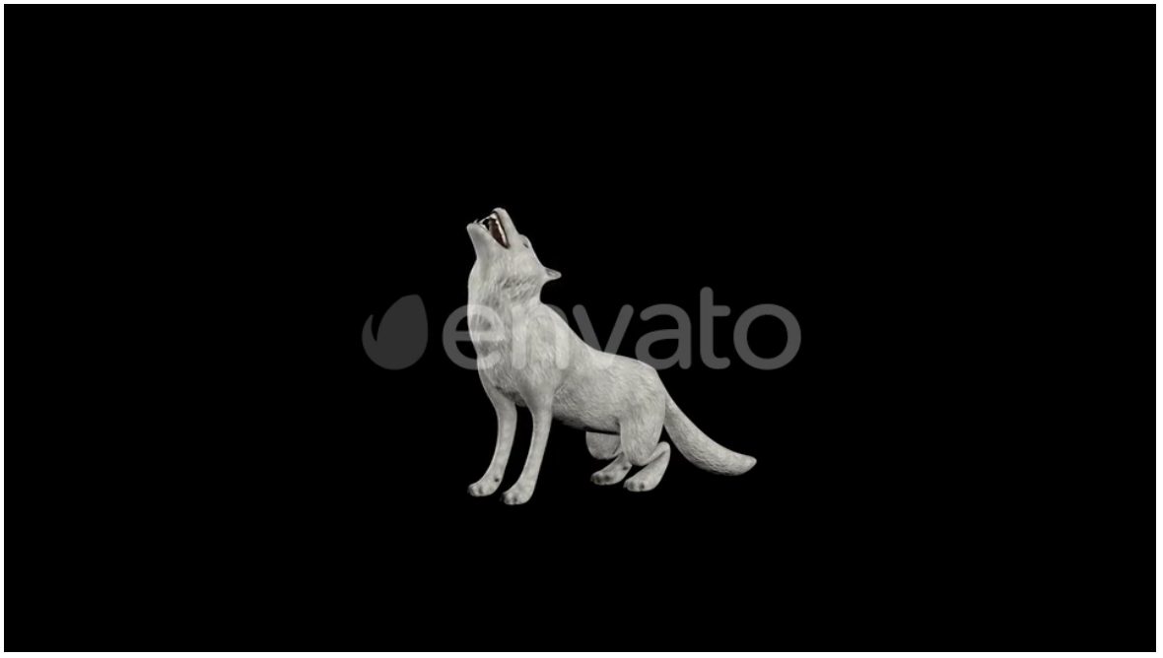

[**https://elements.envato.com/white-wolf-howl-T7VUBGD**](https://elements.envato.com/white-wolf-howl-T7VUBGD)

**User Input:** Scroll Down from last section of Home Page to footer

**Output:** Wolf enters from the right & howls; social icons (IG, FB, LinkedIn, Telephone, Email) fly out of the wolf’s mouth and stack on top of one another on the left side of screen; social handles (clickable text) slide out from the icons

**Instructions:**

* Place howling wolf on the right side of screen as in the reference snapshot/link
* Make icons stack on top of one another on the left side of the screen with the respective handles just beside the icons

**Work Page**

**Reference/Inspiration:**

[**https://www.rhythminfluence.com/our-work**](https://www.rhythminfluence.com/our-work)

[**https://www.awwwards.com/inspiration/worksgallery-junni-corporate-site**](https://www.awwwards.com/inspiration/worksgallery-junni-corporate-site)

[**https://www.awwwards.com/inspiration/our-works-brand-vision-1**](https://www.awwwards.com/inspiration/our-works-brand-vision-1)

**Case Studies Page**

**NOTE:**

* **Please refer to the shared Case Study to get an idea of the layout & type of content to be displayed in each case study.**
* **Refer to the second snapshot for an inspiration for the right column of expanded view.**

**Reference/Inspiration: (As shared by Aishwary)**

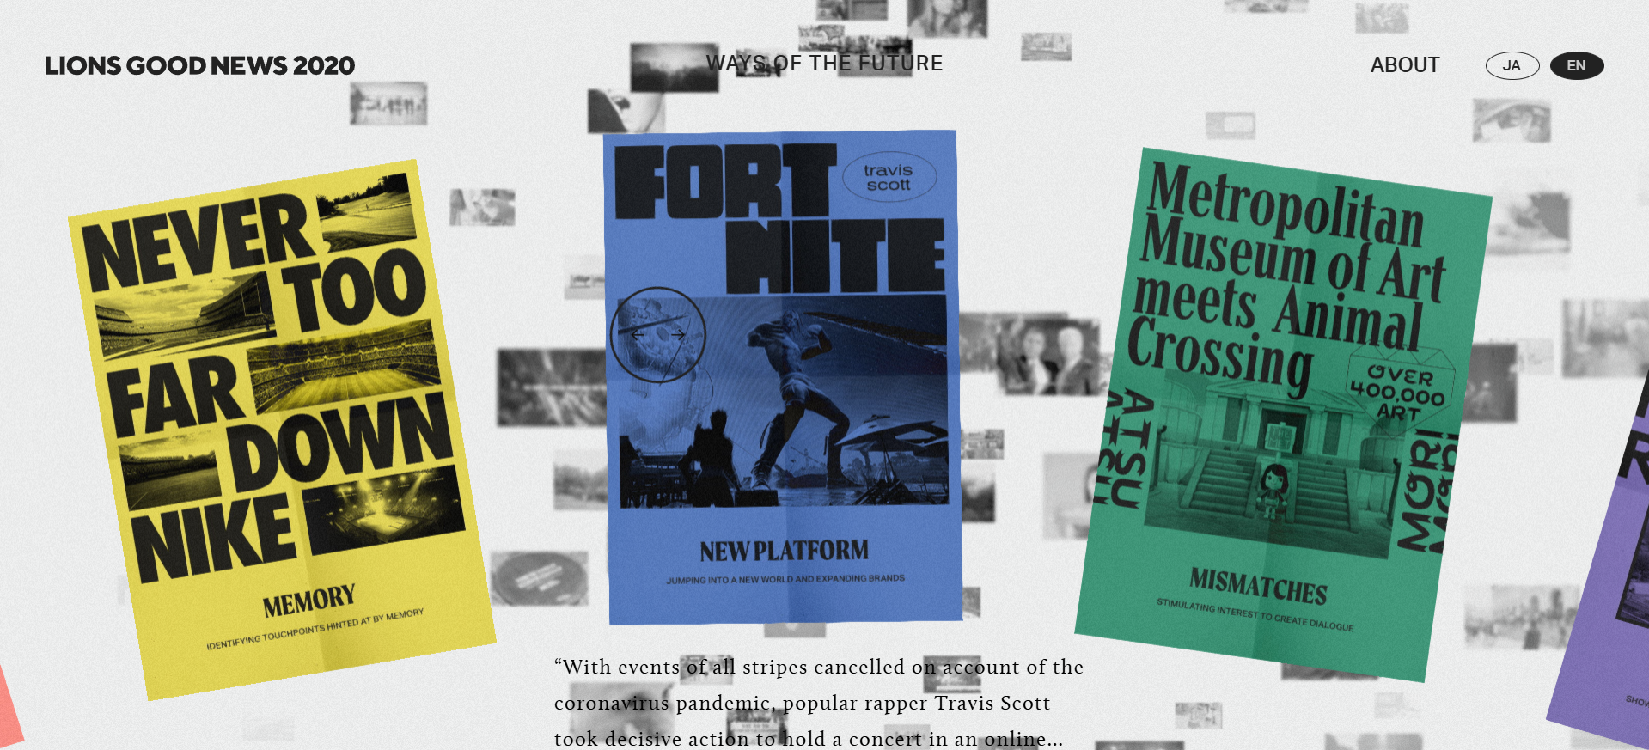

[**https://cannesprlions.com/en/lionsnews/**](https://cannesprlions.com/en/lionsnews/)

**User Input:** Click on Case Studies on Home Page Header

**Output:** Animation with papers flying all around; stops at 3 papers

**Instructions:**

* On each paper; there should be an illustration containing the title of case study
* Make papers pop up when hovered over with the mouse

**Reference/Inspiration: (Expanded View: Right Column)**

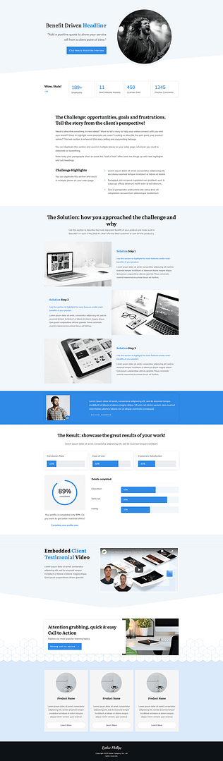

[**https://thrivethemes.com/case-study-template/**](https://thrivethemes.com/case-study-template/)

[**https://www.visionsdesign.co.uk/case-studies/cb-tax**](https://www.visionsdesign.co.uk/case-studies/cb-tax)

**User Input:** Click on any specific Case Study

**Output:** Animation with paper flipping and zooming in; hence, opening the case study

**Instructions:**

* Make the right column a table of contents wherein we have the sub-headings of the respective case study
* Make left column normal content with illustrations; scrollable
* Make sure when someone clicks on a specific sub-heading in the table of contents; the right column scrolls down to the respective section

**Insights Page**

**Reference/Inspiration:**

[**https://www.herocollective.co/latest**](https://www.herocollective.co/latest) **(Cards & Expanded View)**

[**https://www.abodigital.io/news**](https://www.abodigital.io/news) **(Overall UI/UX & Layout)**

[**https://lvcidia.xyz/journal/**](https://lvcidia.xyz/journal/) **(Animation)**

[**https://lark.de/#news**](https://lark.de/#news) **(First Section for Sliding Blogs)**

[**https://ons.limburgsmuseum.nl/en**](https://ons.limburgsmuseum.nl/en) **(Expanded View)**

**Instructions:**

We need three sections on the page:

* The first one featuring our latest blogs along with featured blogs.
* The second section shall be news articles regarding the marketing industry.
* The third section will contain news articles regarding the AI/Tech world.

**About Us Page**

**Reference/Inspiration:**

[**https://momenthumagency.com/get-in-touch/**](https://momenthumagency.com/get-in-touch/) **(for initial/loading animation)**

[**https://designex.ae/about-us/**](https://designex.ae/about-us/) **(for section with all pictures of office)**

[**https://www.andmore.swiss/team**](https://www.andmore.swiss/team)

[**https://www.fl-ex.co.kr/about**](https://www.fl-ex.co.kr/about) **(The floating image)**

[**https://www.jackelder.design/#pixel-scroll**](https://www.jackelder.design/#pixel-scroll)

[**https://thefirstthelast.agency/about**](https://thefirstthelast.agency/about)

[**https://www.qrefinish.com/en/about**](https://www.qrefinish.com/en/about)

[**https://www.lab721.com.br/o-lab721**](https://www.lab721.com.br/o-lab721)

[**https://www.julianfella.de/about**](https://www.julianfella.de/about) **(The text-image animation)**

**Let’s Talk Page**

**Reference/Inspiration:**



[**https://www.dialedweb.com/**](https://www.dialedweb.com/) **(for globe & office locations)**

[**https://www.julianfella.de/contact**](https://www.julianfella.de/contact) **(for expanded view of each form)**

[**https://ranlus.fr/about/**](https://ranlus.fr/about/) **(Overall UI/UX)**

**Instructions:**

* Place the globe with office locations on the left side of screen and make it interactive
* Whenever we hover over an office location, the details including address, email & mobile number appear
* On right side of screen, place cards as shared in the layout inspiration pdf; the cards should pop-up when hovered over
* For expanded view of the form, refer to the link above